DATA STRUCTURES – C PROGRAMMING – 2

1. Write a c program to calculate sum of elements in an array.

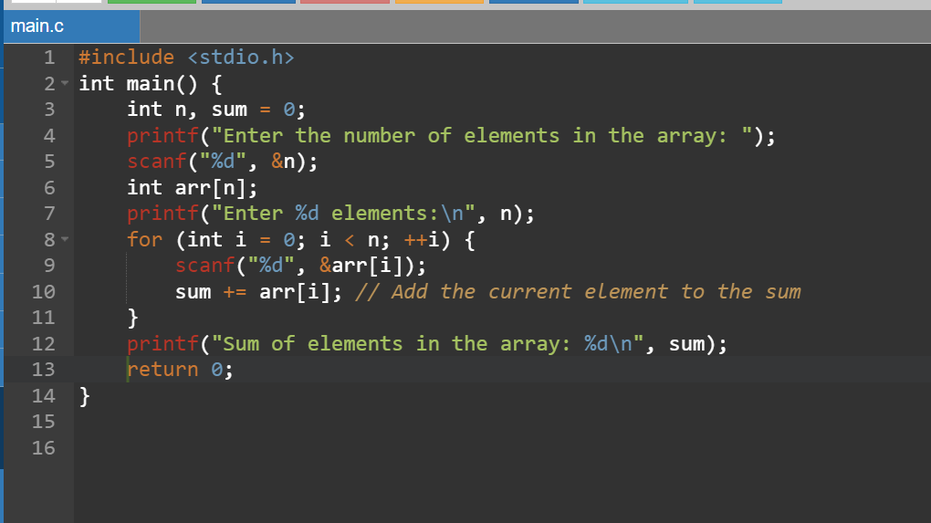

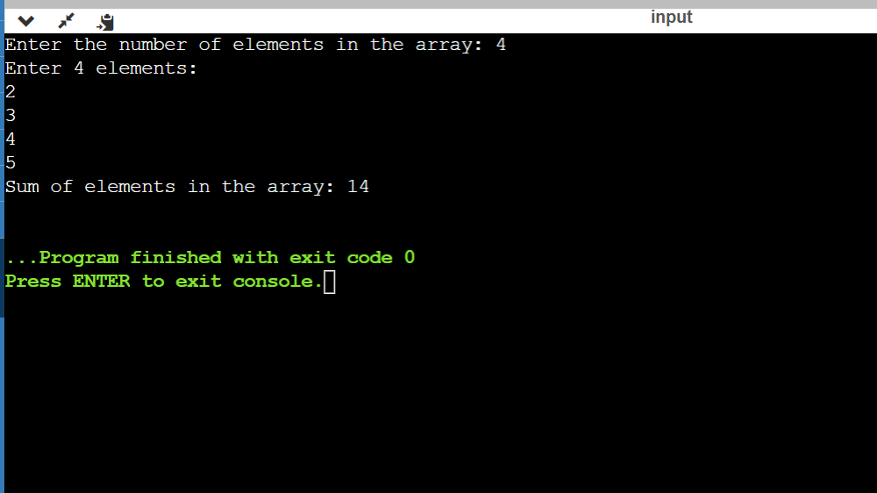

1. Write a c program to merge two array.

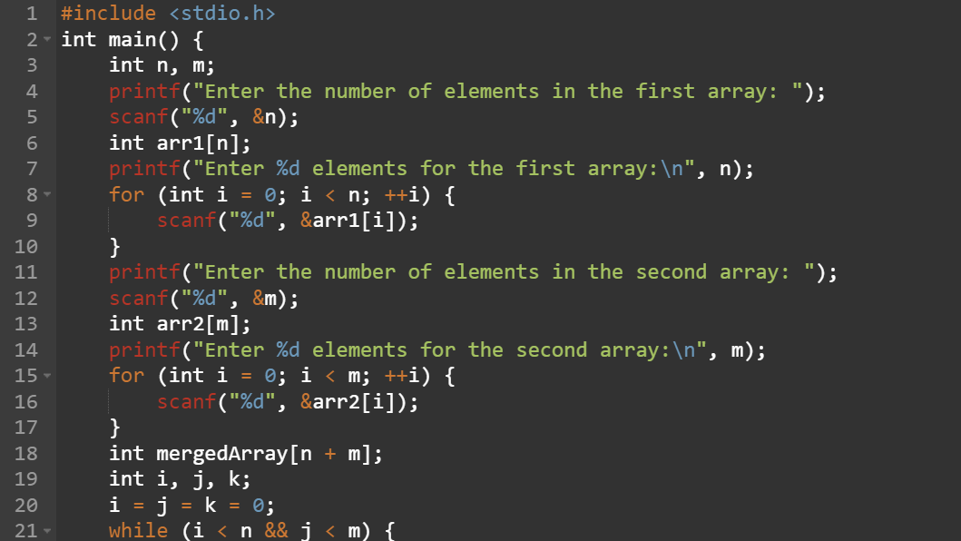

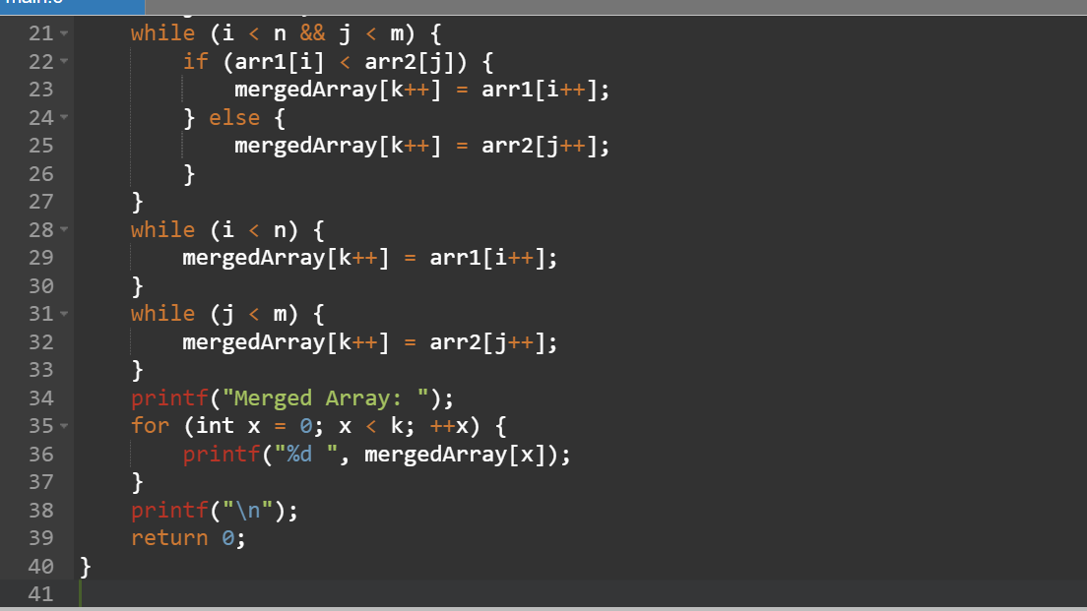

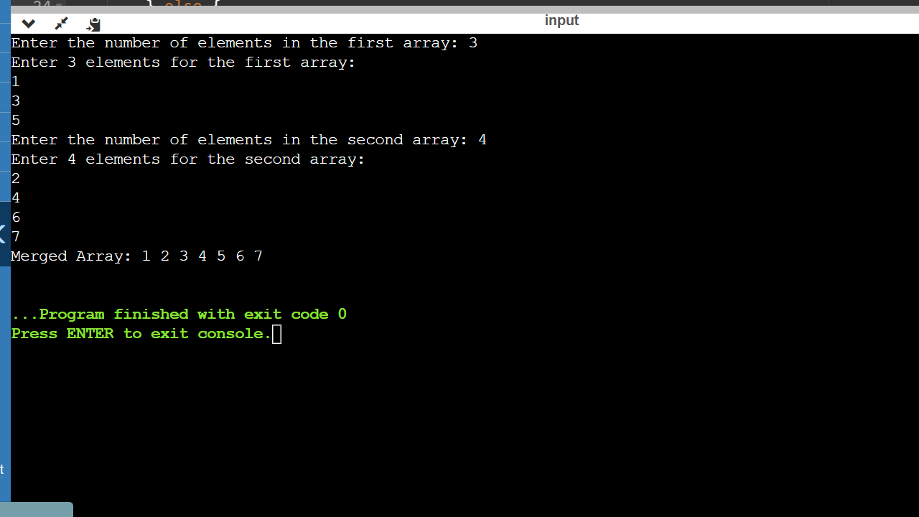

1. Write a c program to perform insertion and deletion of the elements in the middle of the array.

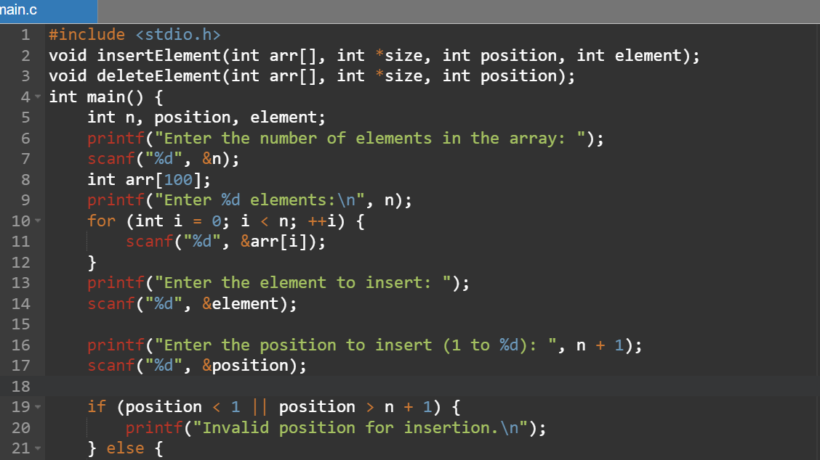

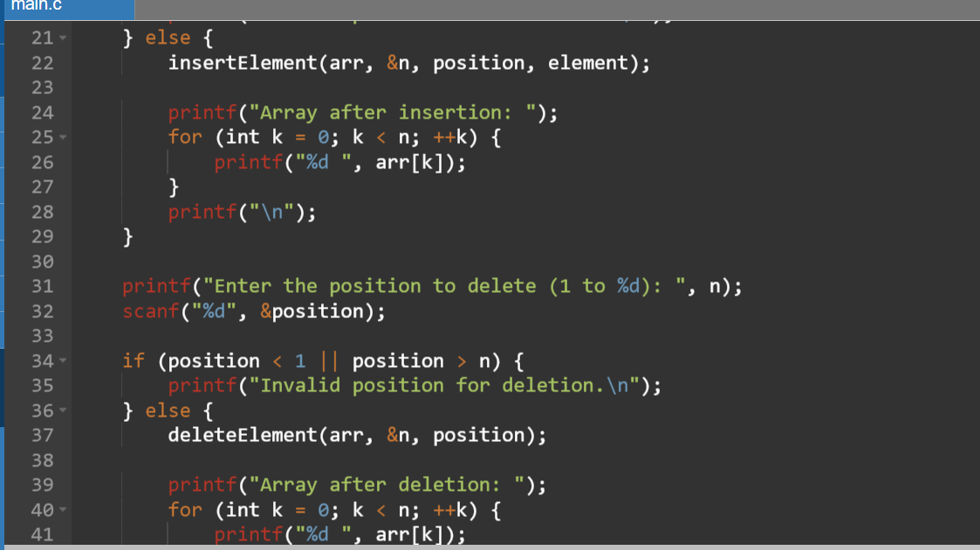

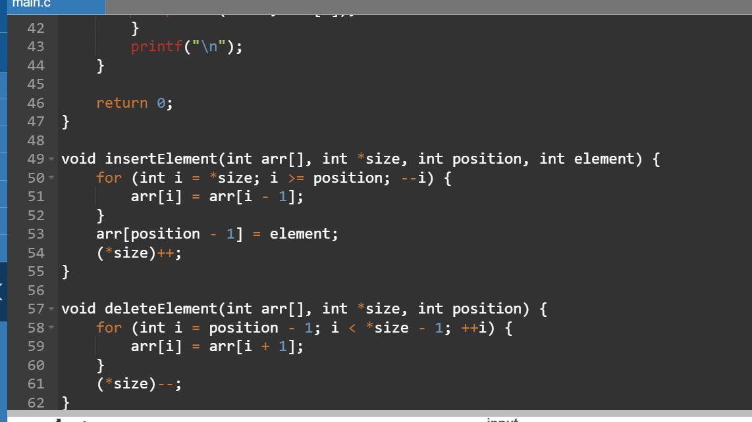

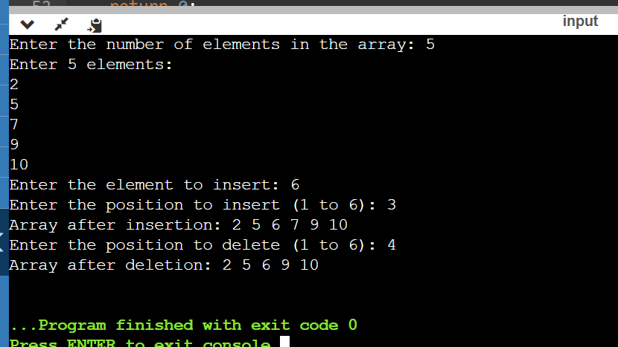

1. Write a c program to reverse a string.

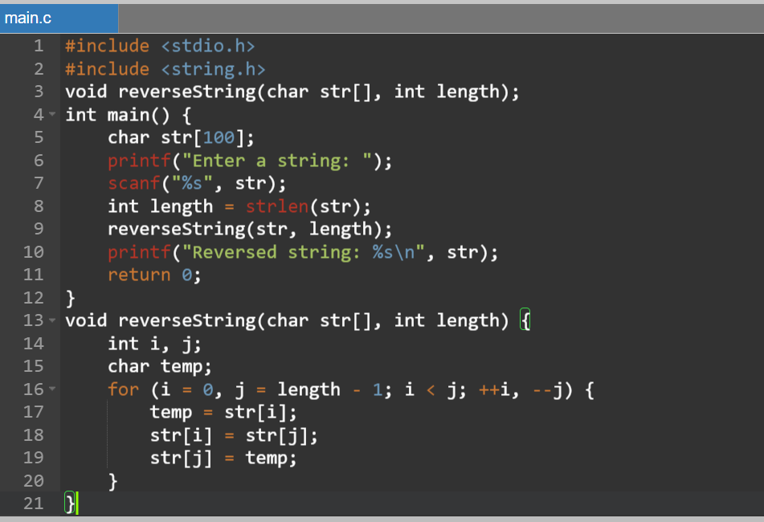

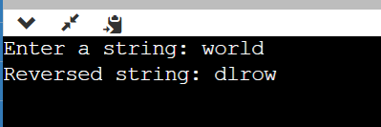

1. Write a c program to check the given string is palindrome or not.

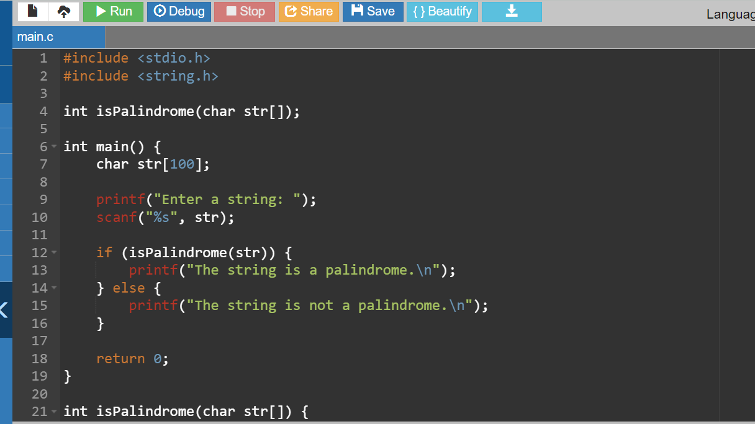

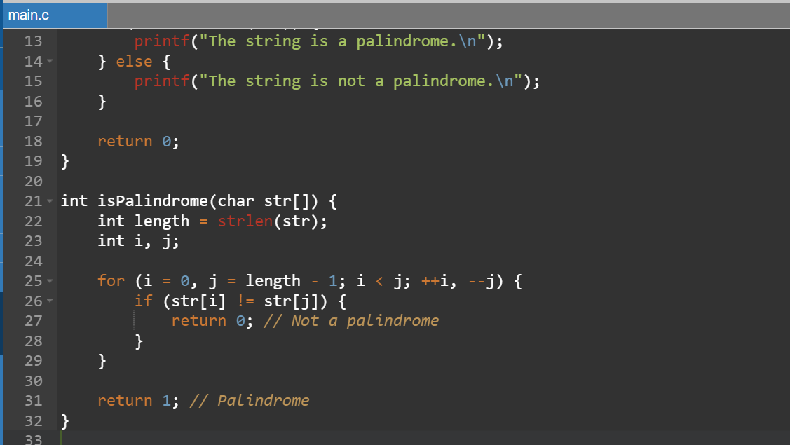

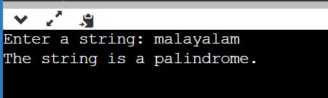

1. Write a c program to search for a particular character in a string.

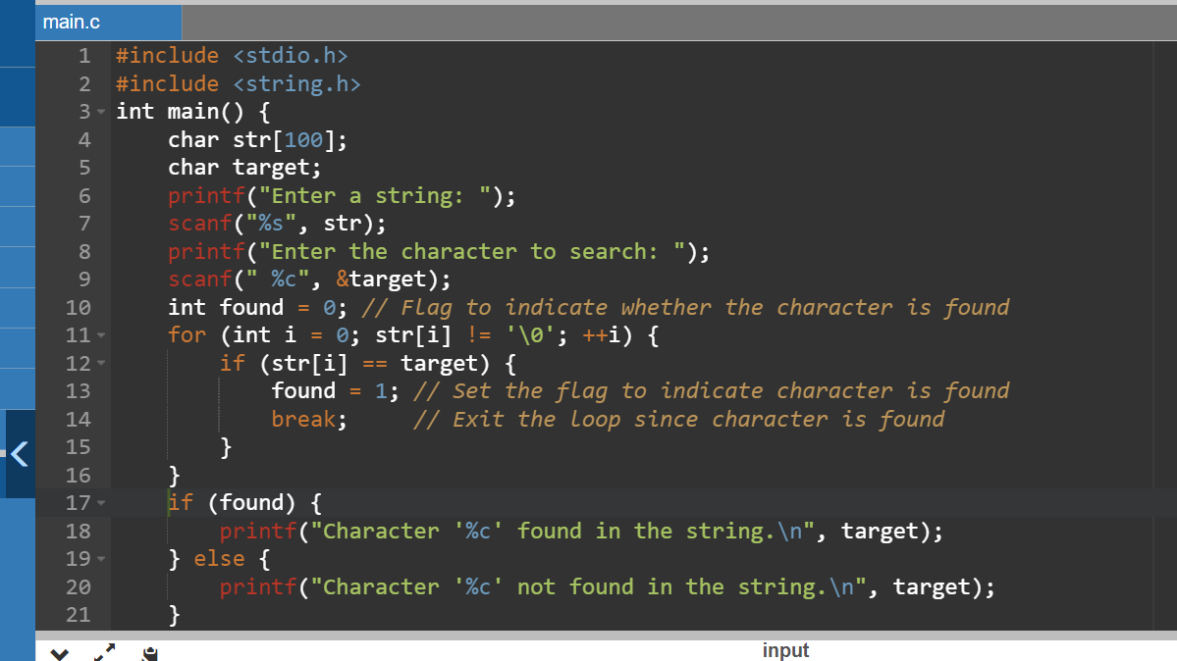

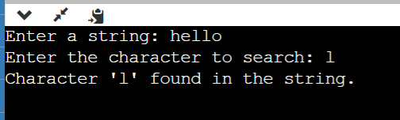

1. Write a c program to count the number of lines a,e,I,o,u present in the string.

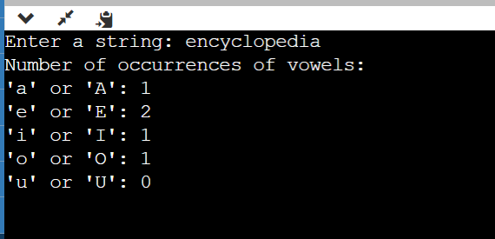

1. write a c program to perform matrix multiplication.

1. write a c program to perform all string manipulation.

